Question 2 Relational Algebra Expessions

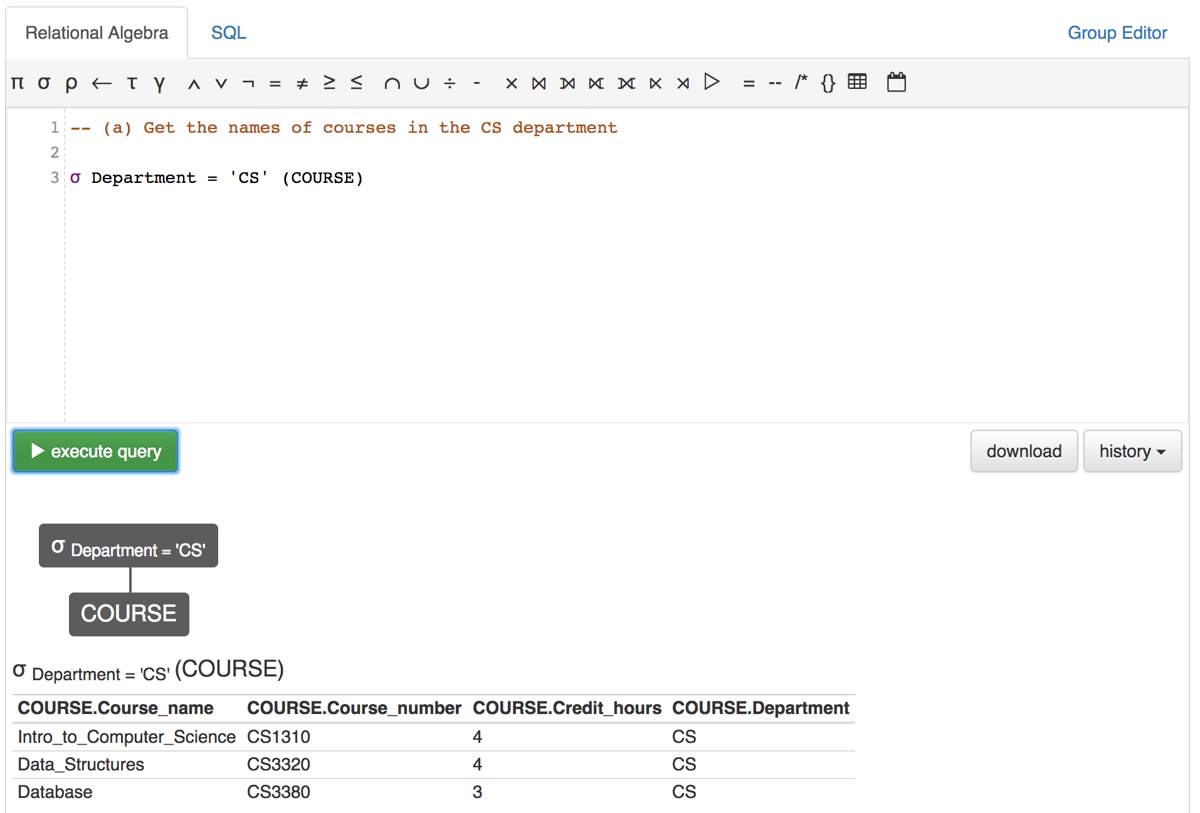

Figure1: Q2/a Expression & Output

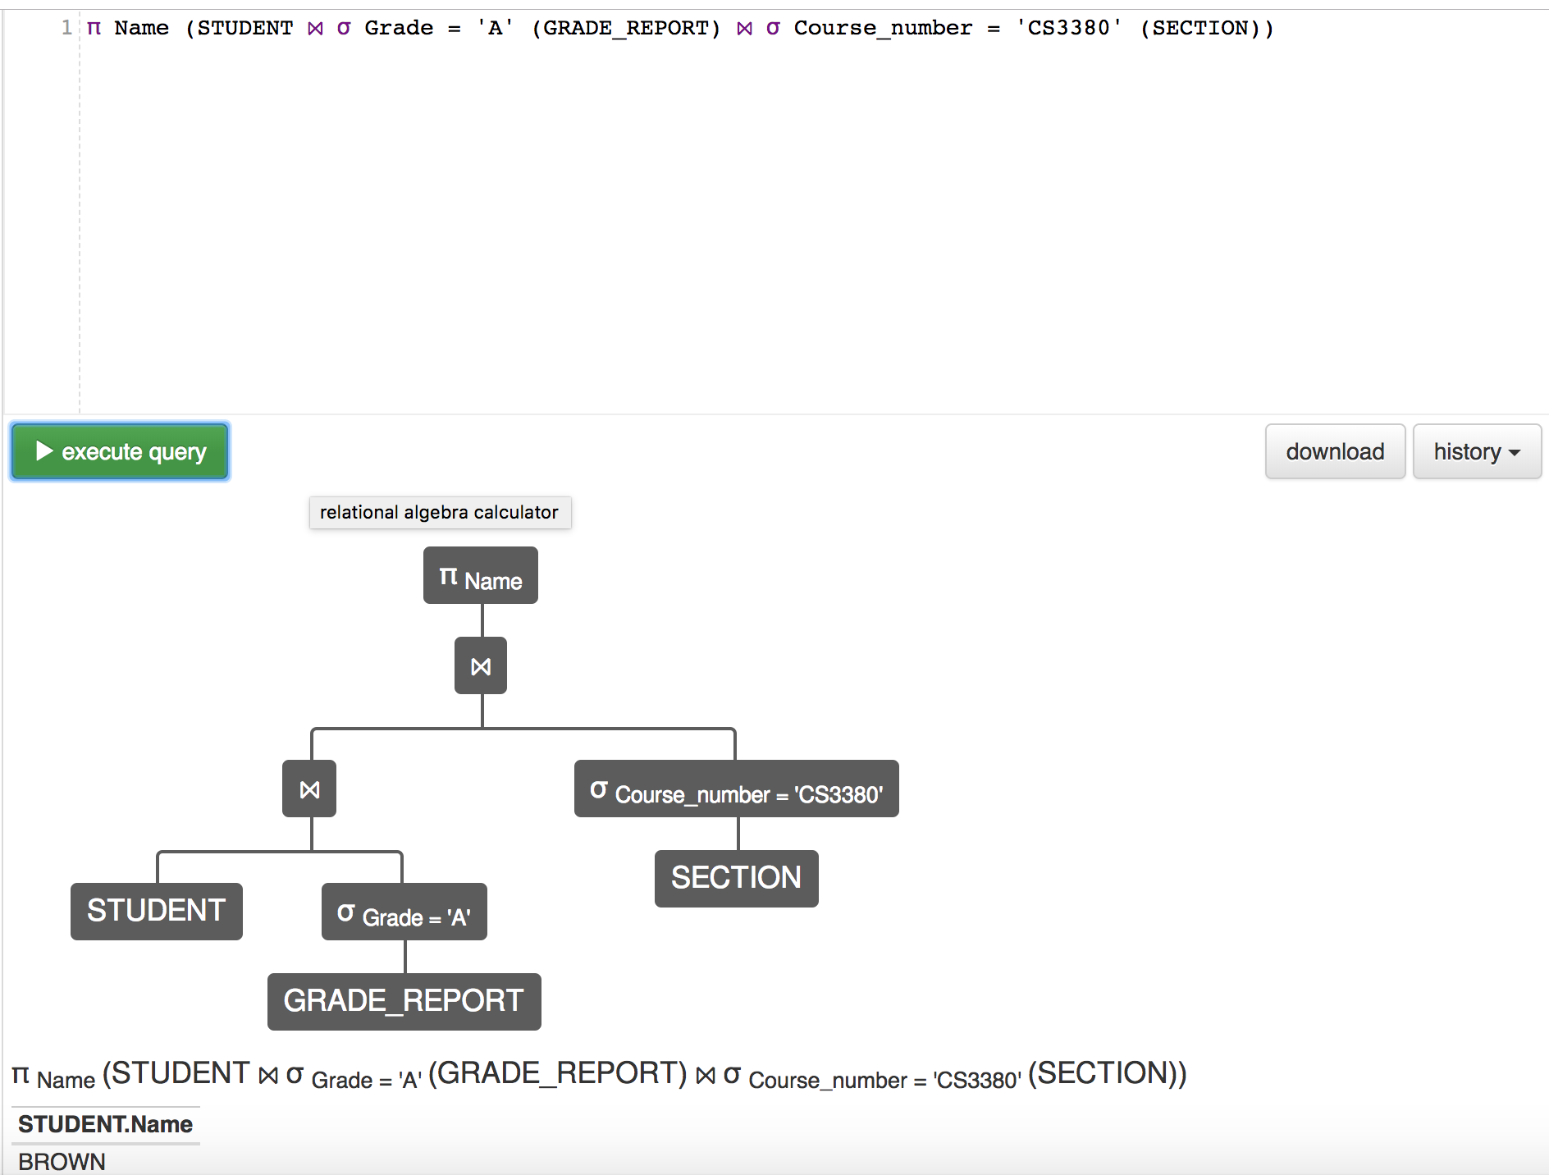

Figure2: Q2/b Expression & Output

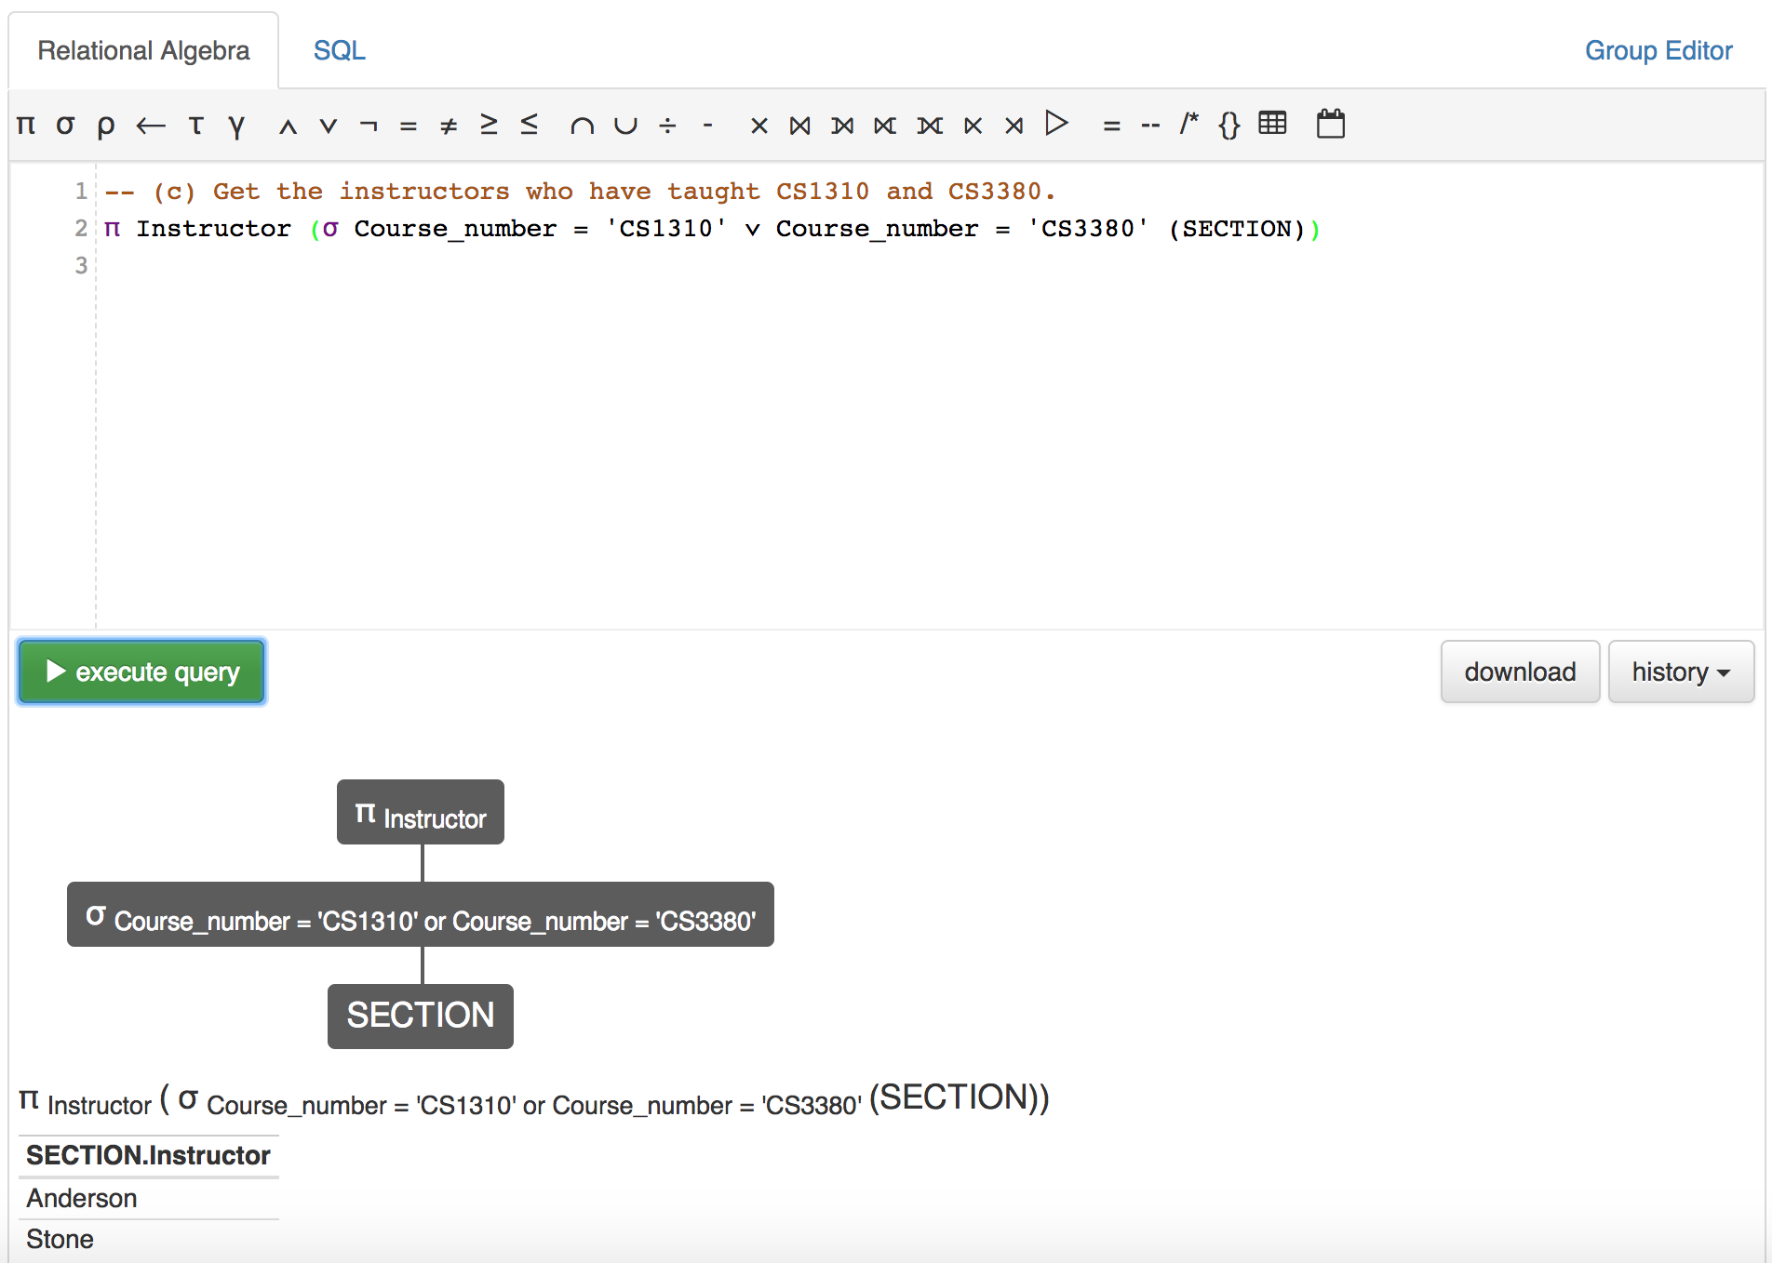

Figure3: Q2/c Expression & Output

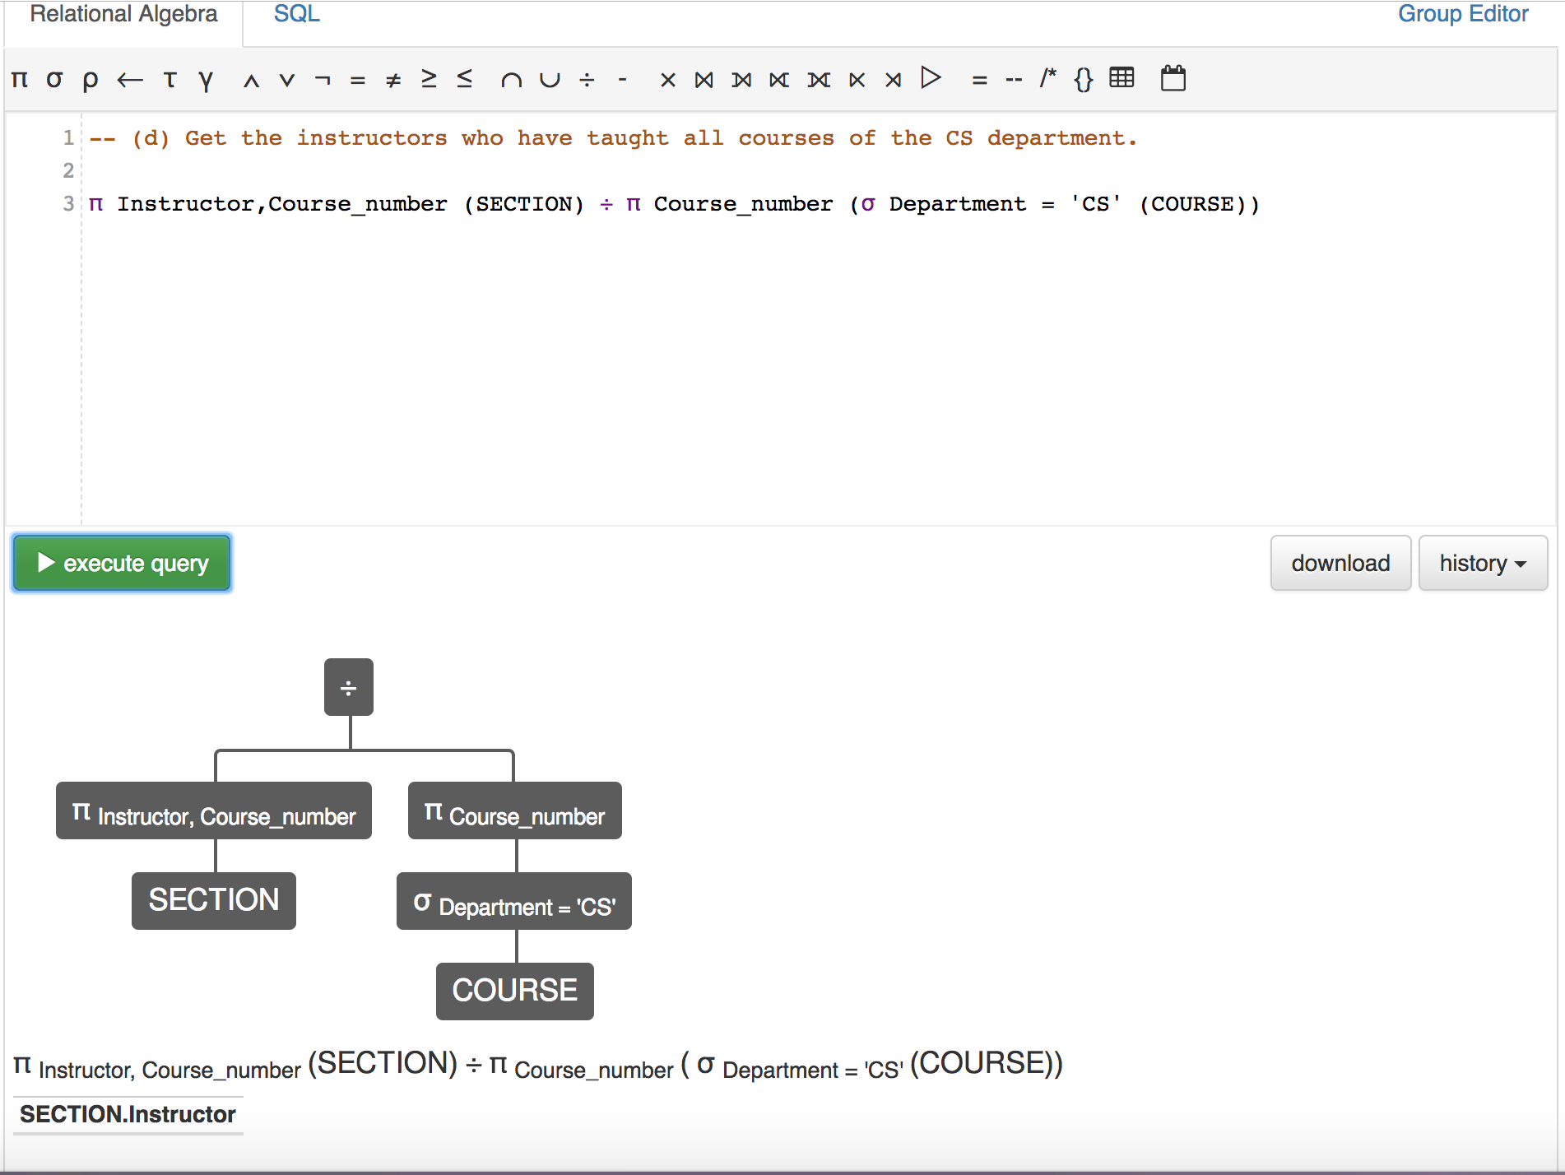

Figure4: Q2/d Expression & Output